1. **Agenda**: Just Theory Part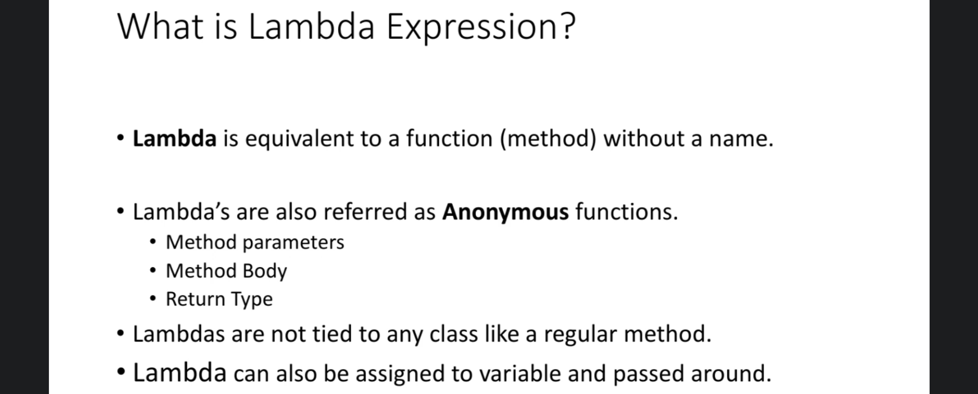
2. 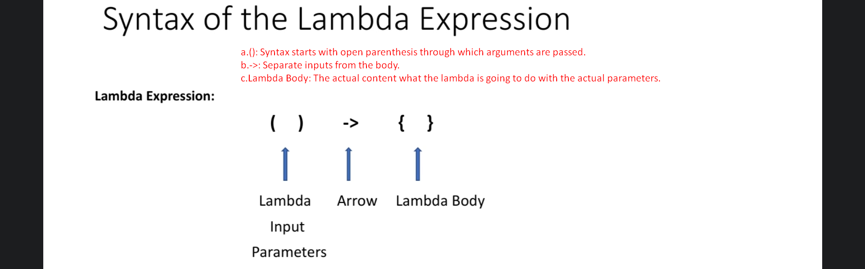
   1. (): Syntax starts with open parenthesis through which arguments are passed.
   2. ->: Separate inputs from the body.
   3. **Lambda Body**: The actual content what the lambda is going to do with the actual parameters.
3. **Usages of Lambda**:
   1. Main purpose of lambda is to implement functional interfaces.
   2. 